TEAM5OIES

SE Team Project with Line Numbers

Version 1.0

TEAM?OIES (Online International Evar System) is a web site with large scale database of EVAR (EndoVascular aortic Aneurysm Repair) data

The TEAM?OIES web site should be designed using these principles:
Text must be grammatically sound and spelled correctly. Poor spelling loses credibility points straight away. Ensure that there is plenty of well laid out textual content on the site to attract search engines as well as to inform prospective clients.
Use keyword and key phrase rich text; that is, utilize copy that includes common phrases that people would enter into search engines when performing a query.
TEAM?OIES needs to be viewable from at least Chrome and Firefox browsers.
Images are a wonderful medium to assist in the online application, especially useful to those clients with poor literacy levels or who are in a rush, as we all seem to be these days. But remember, while a picture may be worth a thousand words in the offline world, its worth next to nothing when it comes to search engines as spiders do not 'see' pictures.
Image HTML coding should also contain 'alt' tags. This is a textual representation of the image which is useful for the situations where the image doesn't load for some reason. Search engines spiders also latch on to this content, especially if the image is linked to another page. 'alt' text will also pop up when a visitor moves their mouse over the image. Client requires that pictures and videos be used in TEAM?OIES.
TEAM?OIES site navigation should be simple and all the questions a consumer may ask should be answered along the way. Where possible, adhere to the "three click rule" - that is, a visitor should be able to access any information regarding your service within 3 clicks of any other area of your web site.
TEAM?OIES should take advantage of the Javascript and Ajax technologies.
TEAM?OIES implements a live online support chat allowing communication of visitors and customers with TEAM?OIES Customer Service over the Internet in real time directly from TEAM?OIES web site. No chat information will be stored in the database.
TEAM?OIES web site will have at least the following pages “TEAM?OIES” home page, “About Us” page, “Contact Us” page, “Testimonials” page with a search function. Testimonials are stored in the database. The search is done by a stored procedure.
TEAM?OIES project must be developed according to the principles and techniques described in COSC 4351. Teams will have 1 TL (Team Leader), 2 DBAs (DataBase Administrator), 2 SQAs (Software Quality Assurance), and 2-4 TMs (Team Members). Teams will be using subversion (SVN) software engineering tool that will facilitate coordination among team members and CCNET (Continuous Integration Build) tool that insures an agile development model.

Reference 1:
Dr. Adeline Schwein “Anatomic and Functional Analysis of a Large Scale Data Base of EVAR to address long term outcome failures“
TEAM?OIES is an interdisciplinary project involving surgeons, medical technicians, computational scientists, software engineers, and other users, generally called customers.
TEAM?OIES is a web based system with a large database backend that will allow uploading patient preoperative and postoperative long term follow-up EVAR data. For the EVAR data quantitative image and flow analysis results can be stored back in the database allowing a surgeon to review these results and to retrieve comparison reports for best decision making. TEAM?OIES will be built using good software engineering practices that will ensure extendibility of new functionality.
The EVAR data goes through these phases:
- Anonymize the data before “uploading” EVAR CT data;
- Upload EVAR CT slice data (about 1 GB per patient) together with annotations about the endograft characteristics;
- Upload EVAR CT data metadata from an Excel file????;
- View EVAR CT data stored in the database; Viewer lists studies, series, and slices of a patient on a list on the left side and the image panel on the right side. The user can select a slice from the left side and can see it on the panel where zoom in/out and multiple display options are available (for example open source software ImageJ can be useful).
- Search the database by patient, search by EVAR CT scan for that patient, search by study, and search by series. Patient can be searched by using patient Id or origin Id (from medical imaging center). EVAR CT scan can be selected from a pulldown of all the Patient’s EVAR CT scans. Study can be searched by using the study Id, original Id, and description. Series can be searched by series id and description. The Customer will provide more feedback as the project evolves;
- Produce an Excel file with the requested information from the database????;
- Download EVAR CT data so that computational scientists can do image analysis whose results will be stored back in the database.
  - Perform automatic quantitative image analysis on the 3D reconstruction by automatically (proprietary software) extracting relevant anatomical data, with 7 measurements:
1. Total volume of the lumen,
2. Partial volume based on a section of the lumen,
3. Coordinates of the skeleton along the artery,
4. Curvature along the skeleton,
5. Angles of bifurcation,
6. Angle of the neck,
7. Area of the sac (aneurysm).
For example, the proximal neck angulation: continuous decreasing or increasing over time, fast decreasing followed by a stable phase, or slow decreasing followed by slow increasing… plasticity is huge.
Also, the evolution of the volume of the sac is important to follow, because its enlargement will be a good predictor of rupture.
- Download data from the database so that computational scientists can do CFD flow simulations whose results will be stored back in the database.
- Perform CFD simulations to provide indicators that help to improve the understanding of the interaction between the aorta, the flow characteristics and the endograft. This could predict poor outcome and reduce secondary interventions after EVAR.
Simulation files for pressure, velocity, and wall shear stress will be generated during this step. They have the .vtu extension.
- View .vtu pressure, or velocity, or wall shear stress with Paraview, on open source software.
- Trigger a database email to be sent to the appropriate surgeon informing him/her that the anatomical and functional analysis results are ready to be viewed.
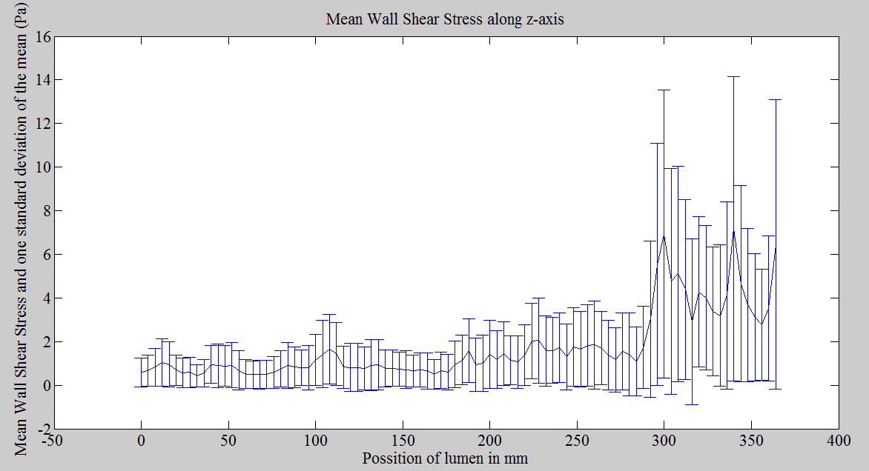

Background on DICOMDIR and DICOM Standards:
Reference 2:
http://what-when-how.com/medical-informatics/a-software-tool-for-reading-dicom-directory-files/
Figure 1: Correspondence between the radiological exam environment and the DICOM Information Model:
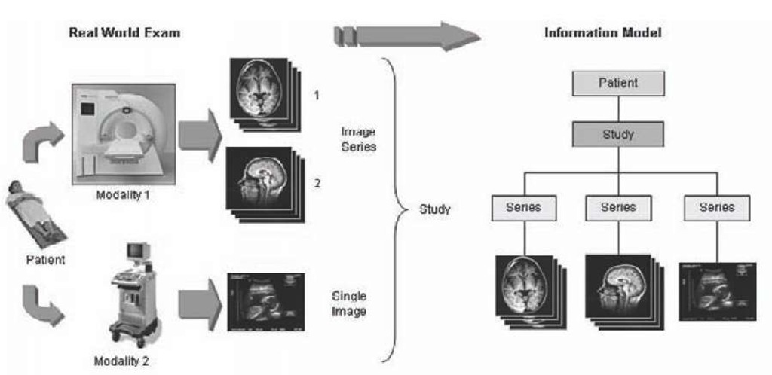
Figure 2: Simplified DICOM application model showing information entities and relationships among them
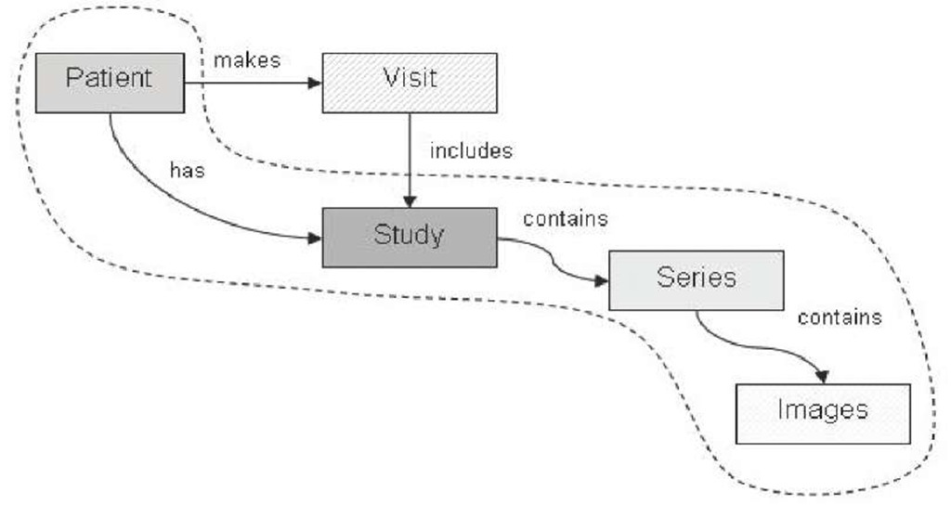
Reference 3:
Toan Nguyen “How to get patient info from DICOMDIR file.docx “follows:
How to get patient info
- Manually
Step 1: Open the run_cdviewer.exe in Patient 7 folder
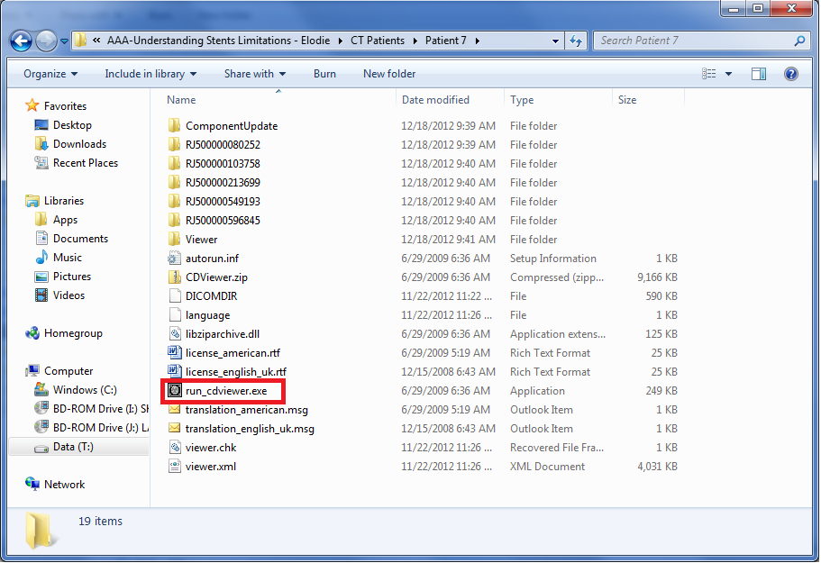

Step 2: Look at the Patient CD Index and see how many examinations and also the date and time of the examinations.
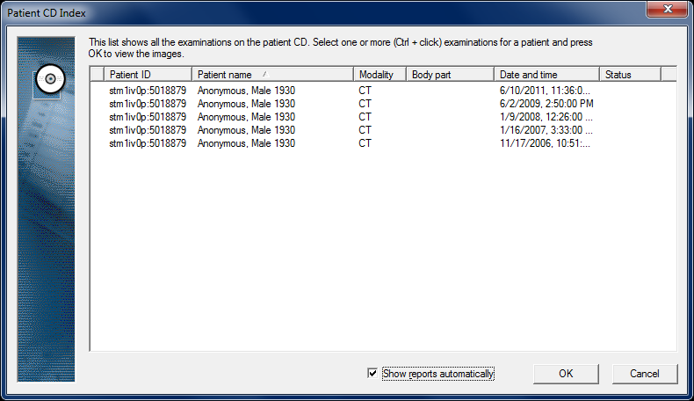

Step 3: Click on the examination then click OK to open Requests and Reports window

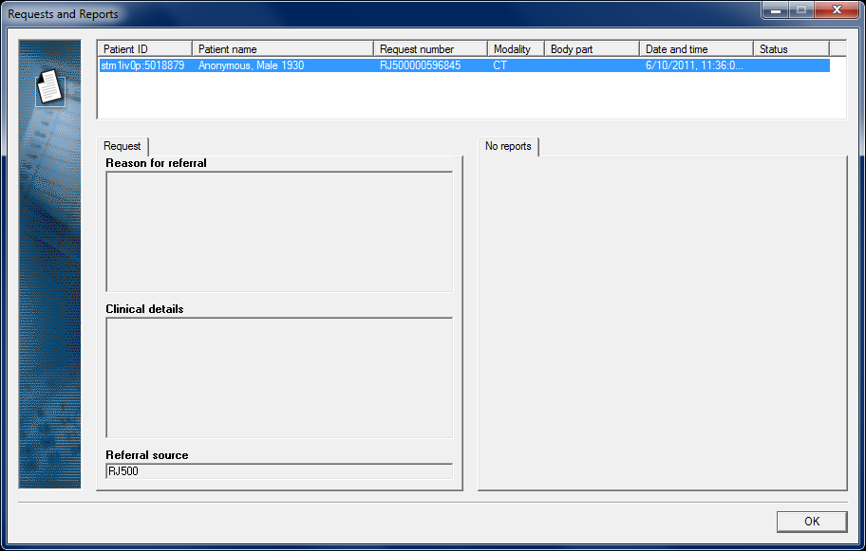

The Request number here (ex: RJ500000596845) is the number corresponding with examination on date 6/10/2011. By using request number, we know which folder contains which examination.
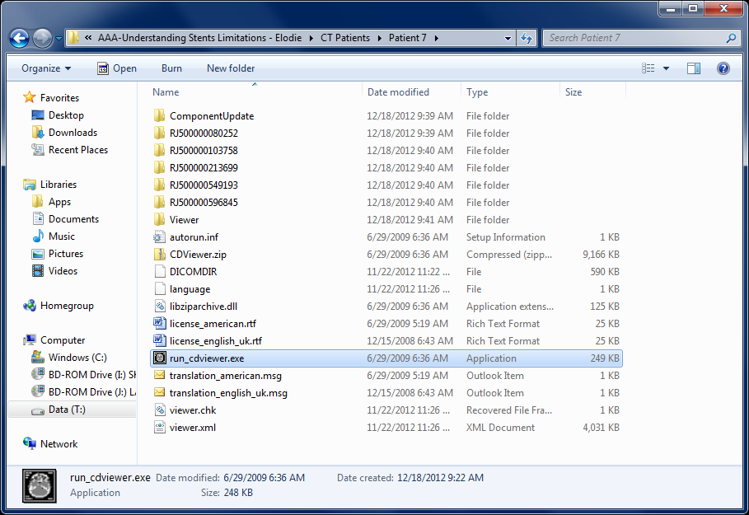

All of other info like: Patient ID (5018879), Name (Anonymous), Birth year (1930), Sex (Male), Number of slides… can easily obtained using the viewer. Contain of the each examination folder is showed in viewer like image below.
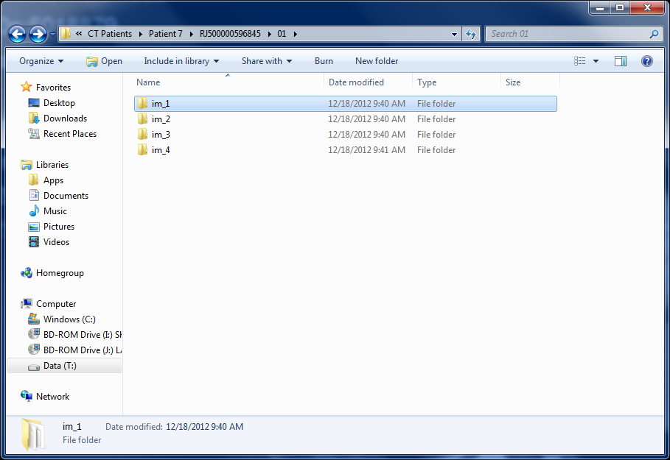

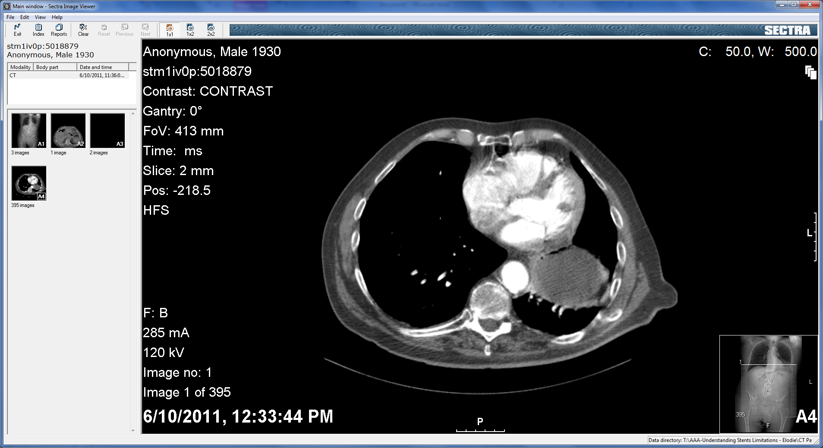
- Automatically

DIRCOMDIR is the DICOM directory file which has all the info of the DVD contained including patient data, image data, file path, etc… Below is what I got using MATLAB to check on the information
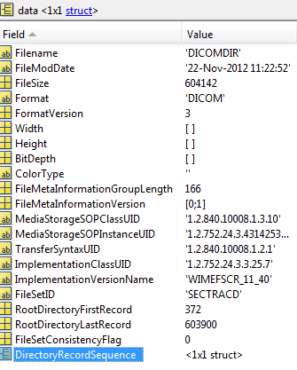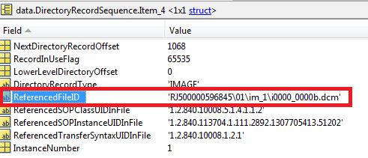

It’s possible to get all the data in DICOMDIR as it is implemented by all CT image viewers. But it requires good understanding how DICOMDIR format is. I hope we can find a good solution for this (open source software such as “Sante DICOMDIR Viewer” or Libraries such as DVMTK that can be used in medical application development)

This is another view of a Patient CT Scans using Sante DICOMDIR Viewer:
DICOMDIR contents based on the files on Patient 11

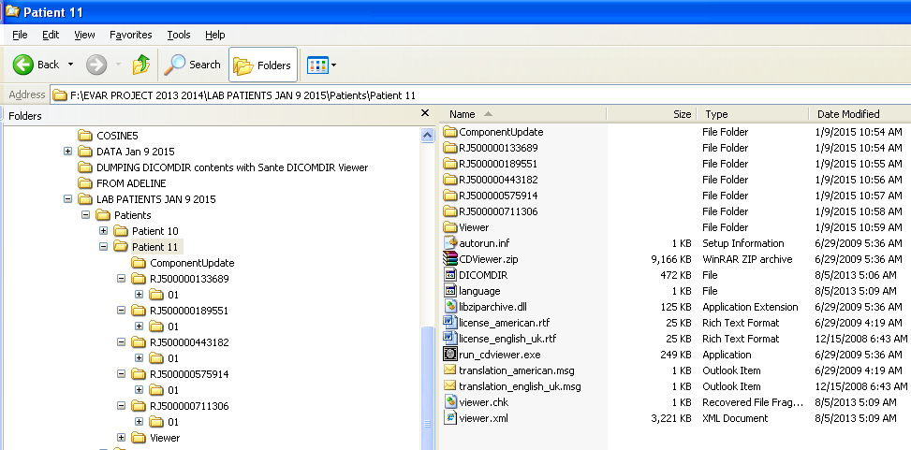
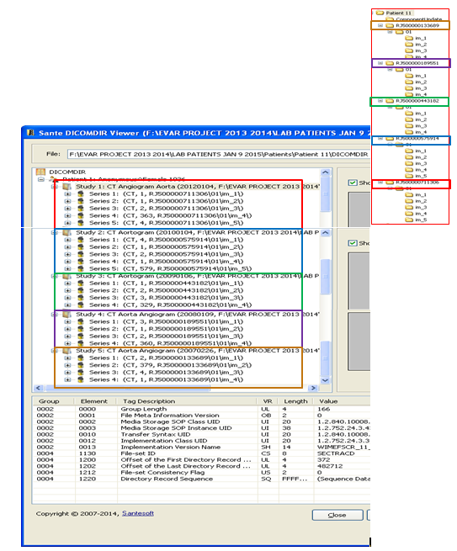

A DICOM file consists of two parts; the header part holds the metadata for patient, image, etc., and the image part holds the image in byte representation. Patient, study, and series information are located in the header part along with extra information. Dicom header can vary in size and include more or less information.
An example Dicom header can be seen below:
0002,0002 Media Storage SOP Class UID: 1.2.840.10008.5.1.4.1.1.2
0002,0003 Media Storage SOP Inst UID: 1.2.840.113619.2.55.3.2831156745.131.1224241599.444.1
0002,0010 Transfer Syntax UID: 1.2.840.10008.1.2.1
0002,0012 Implementation Class UID: 2.16.840.1
0002,0013 Implementation Version Name: MergeCOM3_330
0008,0005 Specific Character Set: ISO_IR 100
0008,0008 Image Type: ORIGINAL\PRIMARY\AXIAL
0008,0012 Instance Creation Date: 20081017
0008,0013 Instance Creation Time: 090224
0008,0016 SOP Class UID: 1.2.840.10008.5.1.4.1.1.2
0008,0018 SOP Instance UID: 1.2.840.113619.2.55.3.2831156745.131.1224241599.444.1
0008,0020 Study Date: 20081017
0008,0021 Series Date: 20081017
0008,0022 Acquisition Date: 20081017
0008,0023 Image Date: 20081017
0008,0030 Study Time: 090026
0008,0031 Series Time: 090207
0008,0032 Acquisition Time: 090222
0008,0033 Image Time: 090224
0008,0050 Accession Number: HEMATURIA
0008,0060 Modality: CT
0008,0070 Manufacturer: GE MEDICAL SYSTEMS
0008,0080 Institution Name: Houston Metro Urology
0008,0090 Referring Physician’s Name: LIGHT
0008,1010 Station Name: hmct
0008,1030 Study Description: ABD PEL W/WO
0008,103E Series Description: ABD WO
0008,1060 Name of Physician(s) Reading Study:
0008,1070 Operator’s Name: KH
0008,1090 Manufacturer’s Model Name: LightSpeed QX/i
0008,1140 Referenced Image Sequence:
0008,1150 Referenced SOP Class UID: 1.2.840.10008.5.1.4.1.1.2
0008,1155 Referenced SOP Instance UID: 1.2.840.113619.2.55.3.2831156745.131.1224241599.442.2
0009,0010 ---: GEMS_IDEN_01
0010,0010 Patient’s Name: XXXX,XXXX
0010,0020 Patient ID: 55539
0010,0030 Patient’s Birth Date: 19830314
0010,0040 Patient’s Sex: M
0010,1010 Patient’s Age: 025Y
0010,21B0 Additional Patient History: ABD PAIN, HEMATURIA
0018,0022 Scan Options: HELICAL MODE
0018,0050 Slice Thickness: 3.750000
0018,0060 kVp: 120
0018,0090 Data Collection Diameter: 500.000000
0018,1020 Software Versions(s): 07MW11.10
0018,1030 Protocol Name: 6.4 Abd/Pelvis WO/W CONTRAST HEMATURIA
0018,1100 Reconstruction Diameter: 500.000000
0018,1110 Distance Source to Detector: 949.075012
0018,1111 Distance Source to Patient: 541.000000
0018,1120 Gantry/Detector Tilt: 0.000000
0018,1130 Table Height: 129.899994
0018,1140 Rotation Direction: CW
0018,1150 Exposure Time: 1052
0018,1151 X-ray Tube Current: 215
0018,1152 Exposure: 43
0018,1160 Filter Type: BODY FILTER
0018,1170 Generator Power: 52800
0018,1190 Focal Spot(s): 1.200000
0018,1210 Convolution Kernel: STANDARD
0018,5100 Patient Position: HFS
0019,0010 ---: GEMS_ACQU_01
0020,000D Study Instance UID: 1.2.840.113619.2.55.3.2831156745.131.1224241599.437
0020,000E Series Instance UID: 1.2.840.113619.2.55.3.2831156745.131.1224241599.443
0020,0010 Study ID: 5606
0020,0011 Series Number: 2
0020,0012 Acquisition Number: 1
0020,0013 Image Number: 1
0020,0032 Image Position (Patient): -269.500\-250.000\-66.000
0020,0037 Image Orientation (Patient): 1.000000\0.000000\0.000000\0.000000\1.000000\0.000000
0020,0052 Frame of Reference UID: 1.2.840.113619.2.55.3.2831156745.131.1224241599.439.1787.1
0020,1040 Position Reference Indicator: XY
0020,1041 Slice Location: -66.000
0020,1208 Number of Study Related Images: 91
0021,0010 ---: GEMS_RELA_01
0023,0010 ---: GEMS_STDY_01
0027,0010 ---: GEMS_IMAG_01
0028,0002 Samples per Pixel: 1
0028,0004 Photometric Interpretation: MONOCHROME2
0028,0010 Rows: 512
0028,0011 Columns: 512
0028,0030 Pixel Spacing: 0.976562\0.976562
0028,0100 Bits Allocated: 16
0028,0101 Bits Stored: 16
0028,0102 High Bit: 15
0028,0103 Pixel Representation: 1
0028,0120 Pixel Padding Value: 63536
0028,1050 Window Center: 40
0028,1051 Window Width: 400
0028,1052 Rescale Intercept: -1024
0028,1053 Rescale Slope: 1
0028,1054 Rescale Type: HU
0040,0244 Performed Procedure Step Start Date: 20081017
0040,0245 Performed Procedure Step Start Time: 090026
0040,0253 Performed Procedure Step ID: PPS ID 5606
0040,0254 Performed Procedure Step Description: ABD PEL W/WO
0043,0010 ---: GEMS_PARM_01
0045,0010 ---: GEMS_HELIOS_01
7FE0,0010 Pixel Data: 3962
------------------------
Title: IM000000
Width: 500.00 mm (512)
Height: 500.00 mm (512)
Resolution: 1.024 pixels per mm
ID: -2
Coordinate origin: 0,0
Bits per pixel: 16 (signed)
Display range: -160 - 240
No Threshold
Calibration Function: y = a+bx
a: -32768.000000
b: 1.000000
Unit: "gray value"
Path: D:\TEAM?OIES \DICOMSTORE\Test1\SE000001\IM000000
Most of the information can be extracted from the DICOM file header directly using i/o operations manually. This approach is effective for few images or series, but it is not efficient for a database which can potentially store thousands of patients and millions of DICOM images. To resolve this issue TEAM?OIES should extract metadata from the DICOM files and insert it into database accordingly. What should be stored in the database is only searchable information as the rest can be read from the file during execution. The reason behind storing metadata is to keep the patient- CT scan-study-series structure and to allow users to search the database.
This is the information that will be stored in the database for patient:
- id (PK– auto incremented),
- originalId (given by the medical imaging center; 0010,0020 Patient ID: 55539),
- firstName (First name of the patient. 0010,0010 Patient's Name: XXXX - anonymized),
- lastName (Last name of the patient. 0010,0010 Patient's Name: XXXX - anonymized),
- birthdate(Birth date of the patient. 0010,0030 Patient's Birth Date: 19830314),
- sex(Gender of the patient. 0010,0040 Patient's Sex: M),
- age,
- entryDate(Current date and time).

This is the information that will be stored for each CT scan for a patient:
- id (PK - 0 – preoperative CT scan, 1 postoperative CT scan 1, 2, etc.),
- dateOfSurgery (date of EVAR Surgery),
- brand (endograft manufacturer, possibly a pull down),
- diameter(endograft body diameter),
- length(endograft body length),
- unilateralLegDiameter(unilateral leg diameter),
- unilateralLegLength(unilateral leg length),
- controlaterLegDiameter(contolater leg diameter),
- controlaterLegLength (contolater leg length),
- entryPoint(left or right leg).

This is the information that will be stored for the study:
- id (PK– auto incremented),
- originalId (Original id of the study assigned by the medical imaging center. 0020,0010 Study ID: 5606),
- description(Description of the study. 0008,1030 Study Description: ABD PEL W/WO),
- modality(Modality of the study. 0008,0060 Modality: CT),
- date(Date when the medical imaging center processed the study.0008,0020 Study Date: 20081017),
- time(Time when the medical imaging center processed the study.0008,0030 Study Time: 090026),
- referringPhysician(Medical imaging studies are done only if they are referred by a physician; thus this field holds the name of that physcian. 0008,0090 Referring Physician's Name: LIGHT),
- institution(Instutition of the referring physcian. 0008,0080 Institution Name:Houston Metro Urology),
- additionalPatientHistory(If the patient has any additional history in the medical imaging center, this information is added to the dicom header. 0010,21B0 Additional Patient History: ABD PAIN, HEMATURIA),
- entryDate(Current date and time).

This is the information that will be stored for the series:
- id (PK – auto incremented),
- originalSeriesId(Original id of the series assigned by the medical imaging center. 0020,0011 Series Number: 2),
- description(Description of the series. 0008,103E Series Description: ABD WO),
- entryDate(Current date and time).

This is the information that will be stored for the slice:
- id (PK– auto incremented),
- inOrder(Order of the slice within the series),
- filename(Name of the dicom file),
- title(Name of the slice. Title: IM000000),
- width (Width of the slice. Width: 500.00 mm (512)),
- height (Height of the slice. Height: 500.00 mm (512)),
- resolution(Resolution of the slice. Resolution: 1.024 pixels per mm),
- coordinateOrigin(Coordinate origin of the slice. Coordinate origin: 0,0),
- bitsPerPixel(Number of bits per pixel. Bits per pixel: 16 (signed)),
- displayRange(Display range of the slice. Display range: -160 – 240),
- fullMetadata(Full metadata), entryDate(Current date and time).

In order to use TEAM?OIES, users must register to obtain a valid account. The user table will be stored in the database to allow authorization and authentication. The userType will allow different roles for the users as follows:
TECHNICIAN: This is the technical person who can enter new studies for a patient. The technician can be a nurse or technical stuff who can get medical images from third party imaging provider and enter them into database.

DOCTOR(Surgeon) : This user is the main target of the system. The doctor should not be bothered with the complexity of the system. They can enter new studies, and patients in the system, view images, edit images, annotate on the images, view patient’s history, and view the anatomical and/or functional data when the analysis is completed (Surgeon will receive an email when the data analysis is completed for a CT scan).

ADMINISTRATOR: This user has control over everything in the system. The only role s/he cannot perform is to see and edit SUPERADMINISTRATOR ‘s information. This user can add studies; edit patients, images; run segmentation, 3D reconstruction, extract anatomical data, run new simulation; and see patient history.
SUPERADMINISTRATOR: This user comes by default with the TEAM?OIES installation had control on everything on the system. Default username and password combination for this user is: superadministrator/123456.
Other information required at registration time is:
- firstName,
- lastName,
- username,
- password,
- email,
- institution (from a drop down menu of institutions to avoid data entry errors; if new institution it can just be typed in)
- active,
- online.
To upload CT scans in the database, the first step is to point to the patient folder.
DICOM files can be recognized by looking at their 128-131 bytes. These specific bytes should include “D”, “I”, “C”, “O”, “M” characters in order to satisfy dicom structure. So non-dicom files are either shorter than 128 bytes or do not include this character set.

Open source APIs are available (example is ImageJ for Java, DVMTK, DicomLib, ) that can extract the dicom structure by following the file/folder tree recursively starting from the root (patient folder). It could look as “/root/dicomdatasets/patient1/study23/series2/img00.dcm”.
A patient can have multiple studies, a study can have multiple series, and a series can have multiple slices as it is dictated in Dicom standard.
User Interfaces of TEAM?OIES must be really friendly and easy to use for the doctors, and at the same time it should provide all necessary functions. TEAM?OIES should came up with a design which hides technical details but shows a friendly environment for the user.

A suggested User Interface that will allow the retrieval of all the Patients(??) stored in the database:
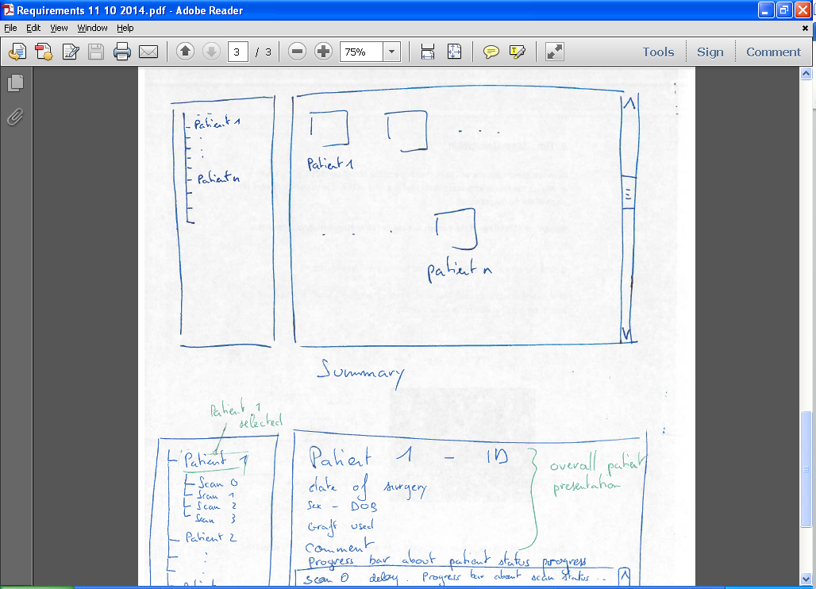

A suggested User Interface that will allow the retrieval of all pertinent information for a particular Patient Number:
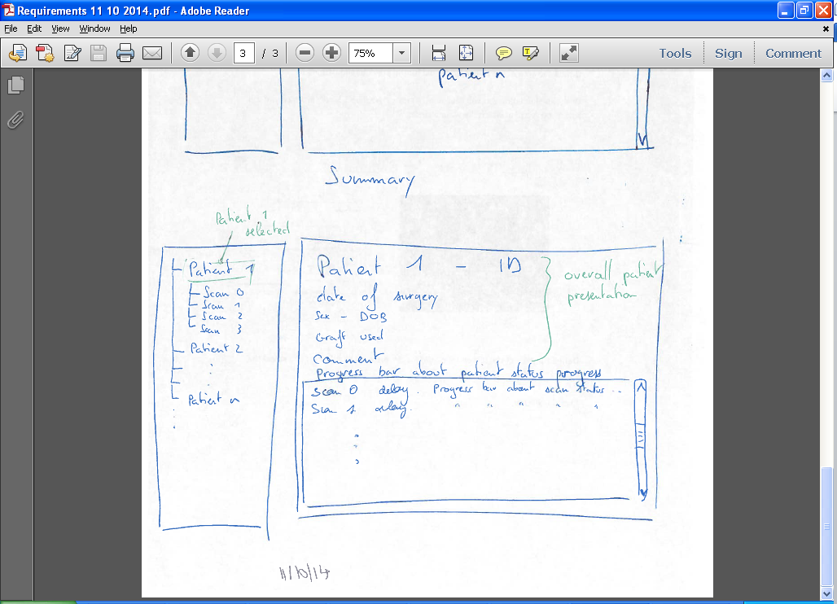

A suggested User Interface that will allow the retrieval of all pertinent information for a particular Patient Number, CT Scan details:
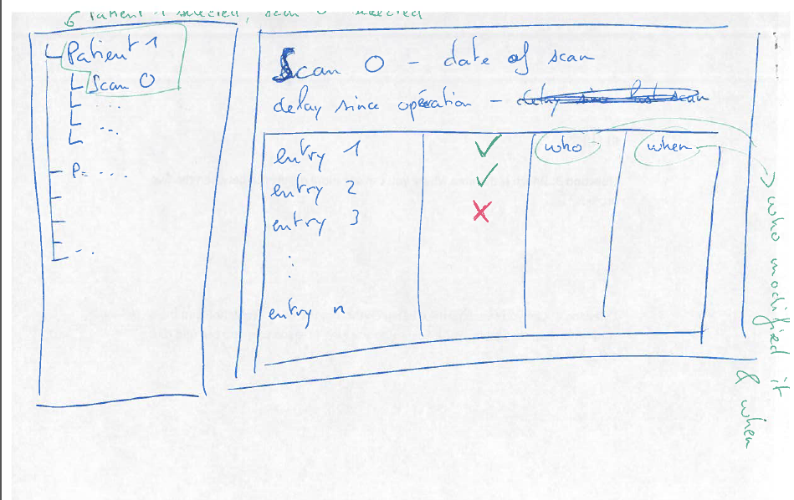
At the Acceptance Testing, a scenario of usage of the TEAM?OIES will be given to you. Data about Patients, EVAR data, etc. will be given to the DBAs for your TEAM?OIES.
The client desires that TEAM?OIES be designed and implemented using OO paradigm. Formal Analysis, SRS (Software Requirements Specification) document needs to be signed by the TEAM?OIES and the client BEFORE any design is started. A SPMP (Software Project Management Plan) document needs to be delivered before the actual development is started.

A prototype is highly desirable. Graphical User Interfaces, Web Site Design, each Page Design can expedite the development process.

An MVC (3 tier architecture) is required.
NOTE: This requirements document “SE Team Project with Line Numbers.doc” might go through revisions based on your questions. There might be missing requirements; there might be unclear requirements, or conflicting requirements. I can take 5 minutes each class to answer possible questions.

Document Control

CHANGE HISTORY

Revision | Name | Date | Description
1.0 | Victoria Hilford, PhD Client | 01/28/2015 | First draft
Dr. Adeline Schwein Customer
Thibault Kensicher Customer
Toan Nguyen Customer
Tuan Ngoc Customer

Document Storage
This file is stored in SVN at https://svn.cs.uh.edu/svn/cosc4351/team7/TEAM PROJECT DELIVERABLES/SE Team Project with Line Numbers.doc.

